5/16/2017

Author: Ryan Breau

V.1.3

PAD Database

Software Design Document

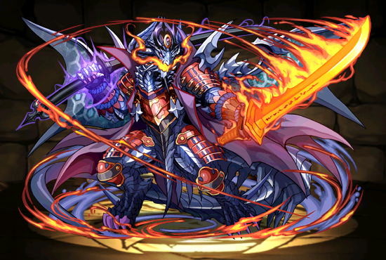

Table of Contents

Revision History 4

1. Introduction 5

1.1 Purpose 5

1.2 Scope 5

1.3 Context 5

1.4 Summary 5

2. References 5

3. Glossary 6

4. Body 7

4.1 Database Architecture 7

4.2 Database Fields, Types and Sizes 7

4.2.1 Attribute Table 7

4.2.2 MonsterType Table 8

4.2.3 LeaderSkill Table 8

4.2.4 ActiveSkill Table 8

4.2.5 AwokenSkill Table 8

4.2.6 AwokenSkillList 8

4.2.7 MonsterClass Table 9

4.2.8 Player Table 9

4.2.9 Badge Table 10

4.2.10 MonsterInstance Table 10

4.2.11 LatentSkill Table 10

4.2.12 LatentSkill List 11

4.2.13 Team Table 11

4.2.14 EvolutionTree Table 12

4.3 Use Cases 12

4.3.1 Admin 12

4.3.2 User 13

**Table of Figures**

Figure 1 Visual Representation of Product Use 5

Figure 2 Database Schema 7

Figure 3 Administrator Use Case 12

Figure 4 User Use Case 13

|  |  |  |  |
| --- | --- | --- | --- |
| Name | Version | Reason for Change | Date |
| Ryan Breau | 1.0 | Created initial SDD Document | 05/11/2017 |
| Ryan Breau | 1.1 | Feedback | 05/12/2017 |
| Ryan Breau | 1.2 | Made additions as well as reorganizing existing information | 05/15/2017 |
| Ryan Breau | 1.3 | Revised existing information as well as added use cases | 05/16/2017 |

# Revision History

# 1. Introduction

## 1.1 Purpose

This document outlines the design of the Puzzle and Dragons database.

## 1.2 Scope

*The product will keep an account of all the Attributes, Types, Active Skills, Leader Skills, Awoken Skills, Latent Skills, Monsters, Monster Evolution Trees, Monster Instances, and Team Instances*

## 1.3 Context

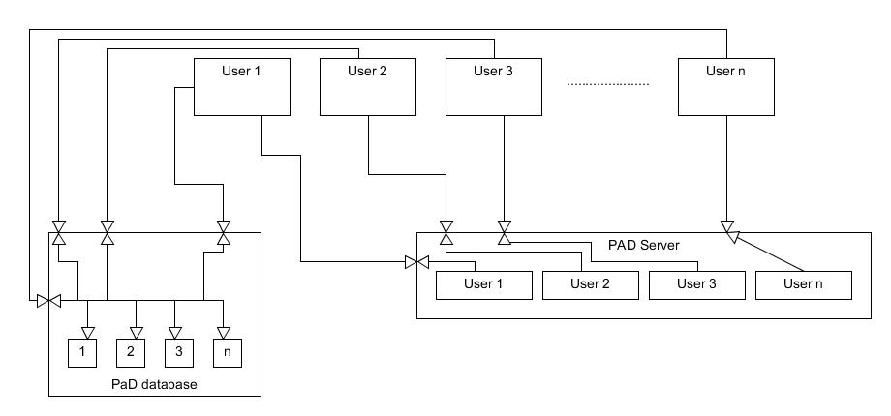

Figure Visual Representation of Product Use

With the PAD server, a player can only see their own progress, monsters, etc.; with our database, player will be able to see the progress, monster, etc. of other players, so long as they update their information. This figure is a visual representation of this.

## 1.4 Summary

The product will be a database consisting of 14 tables.

# 2. References

* Puzzle and Dragons, created by GungHo
* PADX - <http://www.puzzledragonx.com/>
* Puzzle and Dragons Database V1_3

# 3. Glossary

Attribute: Element, a monster will have 1-2 of these.

Types: Monster Classifications, a monster will have 1-3 of these.

Active Skills: An ability a monster can have and use only after a set amount of turns, once used the amount of turns resets.

Leader Skill: A passive ability a monster could have, is only activated when a monster is set as a Leader.

Leader: The first and only necessary monster on a team.

Awoken Skills: Dormant skills a monster can activate when fused with the right monster, passive skills.

Fusion: An action that powers up a base monster using 1-5 other monsters, monster used in a fusion are lost.

Latent Skills: Passive skills given to a monster by fusing a specific type of monster to it, a monster can have up to 5 by default but an extra slot is currently able to be unlocked

Monsters: Cards, creature, characters.

Evolution Tree: The path of evolution a monster can take.

Evolution: An action that takes a base monster and up to 5 additional monsters and create the next/chosen monster in the base monster’s evolution tree, additional monsters are lost upon evolution.

Monster Instance: A monster owned by a user.

Team Instance: A team created by a user.

Team: 1-5 monsters used in dungeons to progress through the game.

+/Plus: An increase to a monster instance’s base stats.

HP: Health Points

ATK: Attack

RCV: Recovery/Receive

PAD: Puzzle and Dragons

NA: North America

# 4. Body

## 4.1 Database Architecture

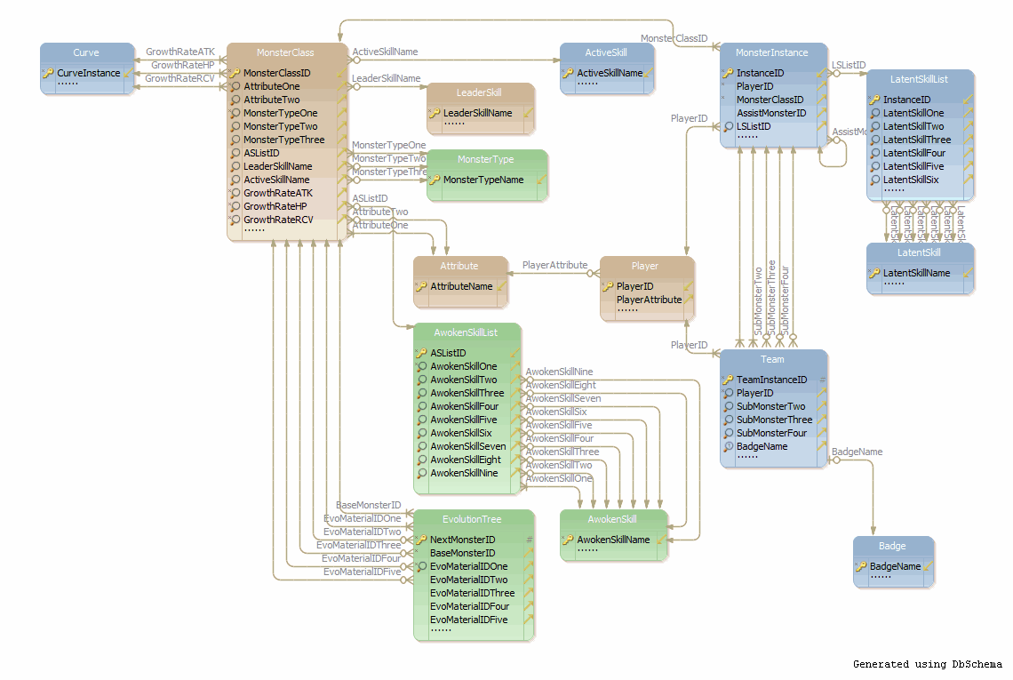

Figure Database Schema

The basic schema for the database. Shows the relationships that will be formed once development begins.

## 4.2 Database Fields, Types and Sizes

### 4.2.1 Attribute Table

|  |  |  |  |  |
| --- | --- | --- | --- | --- |
| Field Name | Data Type | Size | Key | Relationships |
| AttributeName | varchar, not null | 50 | PK | MonsterClass: AttributeOne, AttributeTwo  Player: PlayerAttribute |

### 4.2.2 MonsterType Table

|  |  |  |  |  |
| --- | --- | --- | --- | --- |
| Field Name | Data Type | Size | Key | Relationships |
| MonsterTypeName | varchar, not null | 50 | PK | MonsterClass: MonsterTypeOne, MonsterTypeTwo, MonsterTypeThree |

### 4.2.3 LeaderSkill Table

|  |  |  |  |  |
| --- | --- | --- | --- | --- |
| Field Name | Data Type | Size | Key | Relationships |
| LeaderSkillName | varchar, not null | 50 | PK | MonsterClass: LeaderSkillName  Team: TeamLeaderSkill |
| LeaderSkillDescription | varchar, not null | max |  |  |

### 4.2.4 ActiveSkill Table

|  |  |  |  |  |
| --- | --- | --- | --- | --- |
| Field Name | Data Type | Size | Key | Relationships |
| ActiveSkillName | varchar, not null | 50 | PK | MonsterClass: ActiveSkillName |
| ActiveSkillDescription | varchar, not null | max |  |  |
| ActiveMaxLevel | Int, not null | 2 |  |  |
| ActiveSkillMaxCooldown | Int, not null | 2 |  |  |

### 4.2.5 AwokenSkill Table

|  |  |  |  |  |
| --- | --- | --- | --- | --- |
| Field Name | Data Type | Size | Key | Relationships |
| AwokenSkillName | Varchar, not null | 50 | PK | AwokenSkillList: AwokenSkillOne, AwokenSkillTwo, AwokenSkillThree, AwokenSkillFour, AwokenSkillFive, AwokenSkillSix, AwokenSkillSeven, AwokenSkillEight, AwokenSkillNine |
| AwokenSkillDescription | Varchar, not null | Max |  |  |

### 4.2.6 AwokenSkillList

|  |  |  |  |  |
| --- | --- | --- | --- | --- |
| Field Name | Data Type | Size | Key | Relationships |
| ASListID | Int, not null | 4 | PK | MonsterClass: ASListID |
| AwokenSkillOne | Varchar, not null | 50 | FK | AwokenSkill: AwokenSkillName |
| AwokenSkillTwo | varchar | 50 | FK | AwokenSkill: AwokenSkillName |
| AwokenSkillThree | varchar | 50 | FK | AwokenSkill: AwokenSkillName |
| AwokenSkillFour | varchar | 50 | FK | AwokenSkill: AwokenSkillName |
| AwokenSkillFive | varchar | 50 | FK | AwokenSkill: AwokenSkillName |
| AwokenSkillSix | varchar | 50 | FK | AwokenSkill: AwokenSkillName |
| AwokenSkillSeven | varchar | 50 | FK | AwokenSkill: AwokenSkillName |
| AwokenSkillEight | varchar | 50 | FK | AwokenSkill: AwokenSkillName |
| AwokenSkillNine | varchar | 50 | FK | AwokenSkill: AwokenSkillName |

### 4.2.7 MonsterClass Table

|  |  |  |  |  |
| --- | --- | --- | --- | --- |
| Field Name | Data Type | Size | Key | Relationships |
| MonsterClassID | Int, not null | 4 | PK | MonsterInstance: MonsterClassID, AssistMonsterID  EvolutionTree: BaseMonsterID, EvoMonsterIDOne, EvoMonsterIDTwo, EvoMonsterIDThree, EvoMonsterIDFour, EvoMonsterIDFive |
| MonsterName | Varchar, not null | 50 |  |  |
| Rarity | Int, not null | 2 |  |  |
| AttributeOne | Varchar, not null | 50 | FK | Attribute: AttributeName |
| AttributeTwo | Varchar | 50 | FK | Attribute: AttributeName |
| MonsterTypeOne | Varchar, not null | 50 | FK | MonsterType: MonsterTypeName |
| MonsterTypeTwo | Varchar | 50 | FK | MonsterType: MonsterTypeName |
| MonsterTypeThree | varchar | 50 | FK | MonsterType: MonsterTypeName |
| MaxExperience | Int, not null | 12 |  |  |
| MaxLevel | Int, not null | 2 |  |  |
| MonsterCost | Int, not null | 3 |  |  |
| ASListID | Int | 4 | FK | AwokenSkillList: ASListID |
| LeaderSkillName | varchar | 50 | FK | LeaderSkill: LeaderSkillName |
| ActiveSkillName | varchar | 50 | FK | ActiveSkill: ActiveSkillName |
| MaxHP | Int, not null | 5 |  |  |
| MinHP | Int, not null | 5 |  |  |
| GrowthRateHP | Real, not null | 2 |  |  |
| MaxATK | Int, not null | 5 |  |  |
| MinATK | Int, not null | 5 |  |  |
| GrowthRateATK | Real, not null | 2 |  |  |
| MaxRCV | Int, not null | 5 |  |  |
| MinRCV | Int, not null | 5 |  |  |
| GrowthRateRCV | Real, not null | 2 |  |  |
| MaxCoinValue | Int, not null | 12 |  |  |
| MinCoinValue | Int, not null | 12 |  |  |
| MaxExperienceValue | Int, not null | 12 |  |  |
| MinExperienceValue | Int, not null | 12 |  |  |
| MonsterPointValue | Int, not null | 10 |  |  |
| LSSlots | Int, not null | 2 |  |  |

### 4.2.8 Player Table

|  |  |  |  |  |
| --- | --- | --- | --- | --- |
| Field Name | Data Type | Size | Key | Relationships |
| PlayerID | Int, not null | 9 | PK | MonsterInstance: PlayerID  Team: PlayerID |
| PlayerAttribute | Varchar, not null | 50 | FK | Attribute: AttributeName |
| PlayerName | Varchar, not null | 50 |  |  |
| Rank | Int, not null | 4 |  |  |

### 4.2.9 Badge Table

|  |  |  |  |  |
| --- | --- | --- | --- | --- |
| Field Name | Data Type | Size | Key | Relationships |
| BadgeName | Varchar, not null | 50 | PK | Team: BadgeName |
| BadgeDesc | Varchar, not null | max |  |  |

### 4.2.10 MonsterInstance Table

|  |  |  |  |  |
| --- | --- | --- | --- | --- |
| Field Name | Data Type | Size | Key | Relationships |
| InstanceID | Int, not null | 12 | PK | MonsterInstance: InstanceID  Team: LeaderMonster, SubMonsterOne, SubMonsterTwo, SubMonsterThree, SubMonsterFour |
| PlayerID | Int, not null | 9 | FK | Player: PlayerID |
| MonsterClassID | Int, not null | 4 | FK | MonsterClass: MonsterClassID |
| CurrentExperience | Int, not null | 12 |  |  |
| PlusHP | Int, not null | 2 |  |  |
| PlusATK | Int, not null | 2 |  |  |
| PlusRCV | Int, not null | 2 |  |  |
| SkillsAwoke | Int, not null | 1 |  |  |
| AssistMonsterID | Int | 12 | FK | MonsterInstance: InstanceID |
| SkillLevel | int | 2 |  |  |
| LSListID | int | 12 | FK | LatentSkillList: InstanceID |
| ActiveSkillCooldown | int | 2 |  |  |
| CurrentHP | Int, not null | 5 |  |  |
| CurrentATK | Int, not null | 5 |  |  |
| CurrentRCV | Int, not null | 5 |  |  |
| PlusHPAmount | Int, not null | 3 |  |  |
| PlusATKAmount | Int, not null | 3 |  |  |
| PlusRCVAmount | Int, not null | 3 |  |  |
| CurrentLevel | Int, not null | 2 |  |  |

### 4.2.11 LatentSkill Table

|  |  |  |  |  |
| --- | --- | --- | --- | --- |
| Field Name | Data Type | Size | Key | Relationships |
| LatentSkillName | Varchar, not null | 50 | PK | LatentSkillList: LatentSkillOne, LatentSkillTwo, LatentSkillThree, LatentSkillFour, LatentSkillFive, LatentSkillSix |
| LatentSkillDesc | Varchar, not null | Max |  |  |
| LSSlotsReq | Int, not null | 1 |  |  |

### 4.2.12 LatentSkill List

|  |  |  |  |  |
| --- | --- | --- | --- | --- |
| Field Name | Data Type | Size | Key | Relationships |
| InstanceID | Int, not null | 12 | PK | MonsterInstance: LSListID |
| LatentSkillOne | Varchar | 50 | FK | LatentSkill: LatentSkillName |
| LatentSkillTwo | Varchar | 50 | FK | LatentSkill: LatentSkillName |
| LatentSkillThree | Varchar | 50 | FK | LatentSkill: LatentSkillName |
| LatentSkillFour | Varchar | 50 | FK | LatentSkill: LatentSkillName |
| LatentSkillFive | Varchar | 50 | FK | LatentSkill: LatentSkillName |
| LatentSkillSix | Varchar | 50 | FK | LatentSkill: LatentSkillName |
| ExtraSlot | Bit, not null | 1 |  |  |

### 4.2.13 Team Table

|  |  |  |  |  |
| --- | --- | --- | --- | --- |
| Field Name | Data Type | Size | Key | Relationships |
| TeamInstanceID | Int, not null | 12 | PK |  |
| PlayerID | Int, not null | 9 | FK | Player: PlayerID |
| TeamName | Varchar, not null | 50 |  |  |
| LeaderMonster | Int, not null | 5 | FK | MonsterInstance: InstanceID |
| SubMonsterOne | int | 5 | FK | MonsterInstance: InstanceID |
| SubMonsterTwo | int | 5 | FK | MonsterInstance: InstanceID |
| SubMonsterThree | int | 5 | FK | MonsterInstance: InstanceID |
| SubMonsterFour | int | 5 | FK | MonsterInstance: InstanceID |
| BadgeName | varchar | 50 | FK | Badge: BadgeName |
| TeamHP | Int, not null | 8 |  |  |
| FireATK | Int, not null | 8 |  |  |
| WaterATK | Int, not null | 8 |  |  |
| WoodATK | Int, not null | 8 |  |  |
| LightATK | Int, not null | 8 |  |  |
| DarkATK | Int, not null | 8 |  |  |
| TeamRCV | Int, not null | 8 |  |  |
| TeamCost | Int, not null | 4 |  |  |
| TeamLeaderSkill | Varchar | 50 | FK | LeaderSkill: LeaderSkillName |

### 4.2.14 EvolutionTree Table

|  |  |  |  |  |
| --- | --- | --- | --- | --- |
| Field Name | Data Type | Size | Key | Relationships |
| NextMonsterID | Int, not null | 5 | PK |  |
| BaseMonsterID | Int, not null | 5 | FK | MonsterClass: MonsterClassID |
| EvoMonsterIDOne | int, not null | 5 | FK | MonsterClass: MonsterClassID |
| EvoMonsterIDTwo | Int | 5 | FK | MonsterClass: MonsterClassID |
| EvoMonsterIDThree | int | 5 | FK | MonsterClass: MonsterClassID |
| EvoMonsterIDFour | int | 5 | FK | MonsterClass: MonsterClassID |
| EvoMonsterIDFive | int | 5 | FK | MonsterClass: MonsterClassID |
| MinLevel | Int, not null | 2 |  |  |
| Devolvable | Bit, not null | 1 |  |  |
| LevelReset | Bit, not null | 1 |  |  |

## 4.3 Use Cases

### 4.3.1 Admin

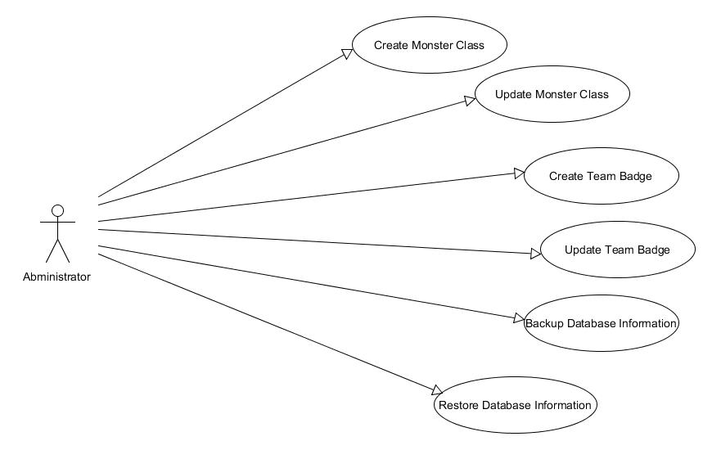

Figure Administrator Use Case

### 4.3.2 User

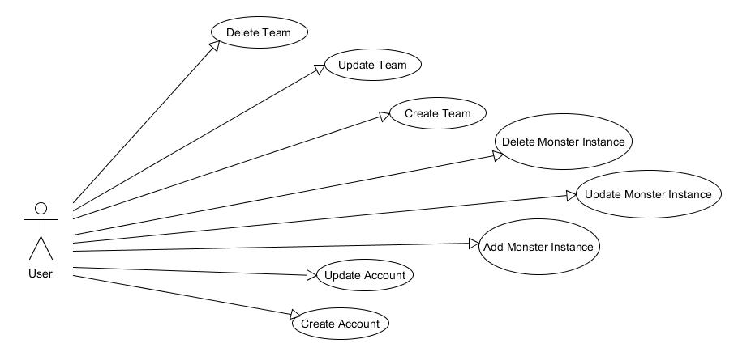

Figure User Use Case